2021

Committee Member
Handbook

Contents

WELCOME 3
INDUCTION INFORMATION 4
VISION 5
MISSION 5
VALUES 5
COMMITTEE CHARTER 6
COMMITTEE TERMS OF REFERENCE 8
COMMITTEE CODE OF CONDUCT 10
COMMITTEE ROLES AND DESCRIPTIONS 11
CONTACTS: 16
Committee Members 16
Club Contacts 17
School Coordinators Contacts 17
2021 WINTER SEASON CALENDAR 18
COURT MAP 19

WELCOME

On behalf of Arawang Netball Association (ANA), I would like to congratulate you on your recent appointment to the ANA Committee.
In welcoming you as a member of our committee, you join a dedicated volunteer base, committed to leading ANA in bringing our vision ‘A successful community driven by people and passion’ to life.
The primary role of the committee is to provide leadership and direction to the association. It is an expectation that at all times members act with integrity and in good faith in fulfilling their duties and make decisions in the best interest of the association.
Key timings for the remainder of 2021 are;

Date | Meeting Type | Time
July 17 | Executive Committee | 3pm (1 hour)
 | General Committee | 4 pm (1 hour)
August 7 | Executive Committee | 3pm (1 hour)
 | General Committee | 4 pm (1 hour)
September 4 | Executive Committee | 3pm (1 hour)
 | General Committee | 4 pm (1 hour)
October 2 | Executive Committee | 3pm (1 hour)
 | General Committee | 4 pm (1 hour)
November 6 (TBC) | Planning Day | TBC
As a member of our committee, it is a requirement to hold a Working with Vulnerable People (WWVP) check. At your earliest, can you please provide either a copy of your WWVP card (front and back), or the application number to arawangnetball@gmail.com.
Included within this induction package is information designed to assist you in your role. Should you have any questions, or requests for further information, please do not hesitate to contact me.
I look forward to the opportunity of working with you in your role
Kind Regards,
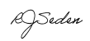
Rondelle Seden
President
Arawang Netball Association
0409 667 655
rondelle.seden@gmail.com.au

INDUCTION INFORMATION

As a committee member you have an important role to play in the administration and success of ANA, as well as enjoyment and wellbeing of all our members.

This handbook is designed to give you all the information that you need in order to fulfil this role, including:

- Association Vision and Mission – draft content included; consultation in progress.
- Committee Charter
- Committee Terms of Reference
- Committee Code of Conduct
- Committee Role and descriptions
- Committee Contact Details
- Clubs and School Contact Details
- ANA 2021 Competition Calendar
- Arawang Court Map

Additionally, please familiarize yourself with the following key information and policies as found on the ANA website;
- ANA Constitution
- ANA Competition Rules
- Wet Weather - ANA notice
- Adverse Weather Policy (NACT)
- Sport Injury Insurance (Netball Australia)
- Member Protection Policy (Netball Australia)
- Social Media Policy (NACT)
- Codes of Behaviour (Netball Australia)
- Inclusion of Transgender and Gender Diverse Athletes in Elite Netball (Netball Australia)

We are committed to working with you to make your involvement and experience a valuable and rewarding one.

Please let us know is there is anything else that will assist in contributing to your position and our broader community.

VISION | A successful community driven by people and passion.

MISSION | We are a positive community, focused on having fun and growing together.

VALUES | INCLUSION, GROWTH & ENJOYMENT through

Strength - Success - Passion - People - Community -
Engagement - Development - Opportunity - Fun - Support

- Values cover grassroots participation to elite representation.
- Ensuring all skill levels, genders and abilities, enjoy the sport we love.

COMMITTEE CHARTER

- Purpose of Charter
  - The Committee Charter sets out the role, composition, and responsibilities of the Committee of Arawang Netball Association (ANA).
  - The conduct of the Committee is also governed by the Constitution/rules of ANA, a copy of which is located at http://arawangna.act.netball.com.au/files/39126/files/Constitution/ana%20constitution.pdf
  - A number of operational matters relating to the Committee such as number of meetings per year, notification of interests, and election of members are governed by the Constitution/rules and are outlined in full in the Committee Terms of Reference.

- Purpose of the Committee
  - The Committee has two overarching purposes, performance, and compliance:

PERFORMANCE: assist the association to perform to its best potential

Strategy and policy
- Approve vision and purpose and ensure it is embedded into the association’s operations
- Approve strategic plan and monitor performance regularly
- Ensure all appropriate policies are in place, current and reviewed regularly
Accountability
- Manage the overall performance of the association through effective decision-making, delegation, and performance of duties
- Manage annual committee evaluation and succession planning
- Manage member and stakeholder engagement and reporting
Public Relations
- Represent and participate
- Keep members and stakeholders informed
- Project a strong and positive image
- Promote the vision
- Facilitate cohesion
- Protect the interests of members and stakeholders
- Speak with one voice regarding committee decisions
Risk Management
- Ensure an up-to-date and effective risk profile and management strategy is in place and reviewed regularly
- Monitor and mitigate principal risks

COMPLIANCE: conform with or exceed all legal requirements

Legal
- Monitor constitution/rules to ensure it remains current
- Comply with Code of Conduct and act dutifully in performing roles and responsibilities
- Comply with all laws in performing roles and responsibilities
- Monitor and manage insurance requirements
Accountability
- Monitor and manage financial responsibilities
- Comply with statutory reporting requirements

  - The Committee, while meeting its responsibilities, is mindful of the associations purpose, vision and objectives as embodied in its Constitution.
- Roles and Responsibilities
  - The Committee has delegated authority for the operations and administration of the association.
  - The functions of the Committee are to:
    - Provide effective leadership in:
    - Articulating the association’s values, vision, purpose, and strategies
    - Developing strategic plans, priorities, and objectives
    - Developing and maintaining an association structure to support the achievement of agreed strategic objectives
    - Review and agree the strategic (and operational) plans and annual budget.
    - Monitor the achievement of the strategic plan and annual budget outcomes.
    - Establish appropriate and effective policies and procedures for members and the association.
    - Ensure all legal compliance obligations and functions are effectively performed.
    - Initiate a committee self-evaluation and succession planning program to assure the committee is comprised of individuals who are able to meet their duties and responsibilities most effectively.
    - Ensure that all significant systems and procedures are in place for the association to run effectively, efficiently, and meet all legal and contractual requirements.
    - Ensure that all significant risks are adequately considered and accounted for through appropriate controls and processes.
    - Ensure that association has appropriate sports governance structures in place.

- Membership and Term
  - The Constitution/rules provides for a minimum of four office bearers and at least three ordinary/general committee members.
  - Any three members of the committee, including at least one office bearer, constitute a quorum for the transaction of the business of a meeting of the committee.
  - Members are free from any interest and any business or other relationship which could, or could reasonably be perceived to, materially interfere with the member’s ability to act in the best interests of the association.
  - Membership of the Committee shall be publicly disclosed including within the Annual Report.
  - In accordance with the Constitution/rules, each member of the committee holds office, subject to these rules, until the conclusion of the annual general meeting following the date of the member’s election but is eligible for re-election.
- Committee Culture
  - The Committee actively seeks to have a culture which is characterised by equality and a willingness to challenge.
    - Agendas
    - The agendas of Committee meetings limit presentation time and maximise discussion time.
    - There are lots of opportunities for informal interactions among Committee members.
    - Behaviours
Committee members;
    - are honest yet constructive.
    - are ready to ask questions and willing to challenge leadership.
    - actively seek out other association members’ views & contributions.
    - spend appropriate time on important issues.

    - Values

The Committee;
    - serves its members by putting their interests first.
    - is responsible to all members and its stakeholders.
    - are personally accountable for what goes on at the association.
    - is responsible for maintaining the association’s stature in the community.
    - respect each other.
- Reporting
  - Proceedings of all meetings are minuted by the Secretary and signed by the Chair of the meeting.
  - Minutes of all Committee meetings are circulated to members and approved by the Committee at the subsequent meeting.
- Review of Charter
  - The Committee will review this charter annually to ensure it remains consistent with the Committee’s objectives and responsibilities.

COMMITTEE TERMS OF REFERENCE

Purpose:
The purpose of the Arawang Netball Association (ANA) is to provide a safe and competitive environment for players, coaches, officials wanting to participate in the game of netball at all levels from participation through to elite levels.

ANA committee members have an important role to play in the administration and success of ANA, as well as enjoyment and wellbeing of all our members.

Background:
Arawang Netball Association (ANA) is one of the five member districts of the ACT Netball Association and has been providing netball facilities and competitions for over 30 years.

ANA is run predominately by volunteers with exception to an Administration Assistant (AA) who is employed for 16-20 hours per fortnight.

ANA runs winter competitions for players of all ages, ranging from NetSetGo! To Seniors. Competitions are held at the Arawang Netball Courts, Stirling. ANA runs the following competitions during the winter (March to September):

Competition | Age Group | Timeslot
Net Set Go | 5 to 7 years | 9.30am
Juniors | 7 to 12 years | 9:45am - 12.00pm
Intermediates | 13 to 17 years | 12.00pm – 2.00pm
Seniors | 18 years and over | 2.15pm – 4.00pm

Summer competitions are run for a limited period throughout November & December each year, depending on interest. A Summer Convenor is a requirement to operate this competition. The decision to operate the competition is at the discretion of the ANA Executive Committee.

Membership:
The ANA Committee is led by an Executive Committee (referenced in the constitution as the Office Bearers), composing of the President, Vice President, Secretary and Treasurer. The Executive Committee holds key responsibility for all decision making.

The ANA President in its lead role, chairs the Committee.

Responsibilities:
The core operational roles and responsibilities for ANA Committee members are defined within specified job descriptions.

Each committee member is required to;
- Provide a brief report 1 week before and attend a monthly Arawang Committee meeting
- Coordinate task outcomes, as agreed/nominated at monthly committee meetings
- Assist with volunteering activities throughout term of the engagement (12 months)

It is the role of the President and/or Vice President to ensure representation of ANA at all NACT or relevant community meetings and report back to the Executive and/or General Committee as appropriate.

It is the role of the Executive Committee to ensure all business aspects of ANA are met. The Executive Committee must table all out of session decisions to the General Committee at each monthly meeting and/or engage additional committee members into the decision making process as required.

The Administration Assistant (AA), employed position, provides administrative support to the Executive Committee as required. Additionally, the AA will coordinate all incoming correspondence with the relevant ANA Committee positions to ensure a response is provided as per requested timeline.

Meetings:
The ANA Committee intends to meet face-to-face monthly or as required to meet its purpose. Invites will be sent at least 2 weeks in advance, when possible, to all committee members confirming time, date and location.

Committee Members holding key roles may be requested to provide brief updates 2 weeks prior to each meeting. With meeting papers distributed to members 1 week prior to meeting (where time permits, or activity requires).

Additionally, the ANA Executive may call for Out of Session approvals between face-to-face meetings.

Agenda items are to be developed collaboratively and approved in advance by the ANA President, or their delegate.

Stakeholder Contact and Communications:
The ANA President, or their delegate, will be responsible to communicate meeting outcomes to Netball ACT (NACT), local/state Governments and other netball associations (as relevant).

ANA will support NACT to enhance and promote opportunities to athletes, players and officials.

The ANA President will be the point of contact for high level communications with NACT, local/state Governments and other netball associations.

Key ANA Committee members will be the point of contact for subject/area specific communications or information.

Review:
ANA Executive intends to review the Terms of Reference prior to the AGM of each calendar year.

COMMITTEE CODE OF CONDUCT

As a committee member, you must:

- Respect the rights and dignity of every person regardless of gender, race, ethnicity or sexual orientation and ensure that the association promotes a safe and inclusive environment.
- Protect the integrity of sport at all times by ensuring that the behaviour and conduct of every person is consistent with the laws of the game, the principles of fair play and the standards of safe and inclusive sport.
- Protect the safety and wellbeing of members at all times by ensuring that appropriate safeguarding measures and policies are in place, easily accessible and understood by every person, and reviewed regularly.
- Be impartial, consistent and transparent in your conduct and decision-making. Accept responsibility for your actions.
- Make decisions in the best interests of your members and the sport.
- Promote a safe and inclusive environment, in which every person feels welcomed and is protected and free from discrimination, harassment and abuse.
- Ensure that all players, coaches, officials, parents and spectators place wellbeing and enjoyment ahead of performance and outcomes.
- Create pathways that support players, coaches and officials to improve their skill development.
- Provide equal opportunities for all players, coaches and officials to participate, regardless of their gender, ability or cultural background.
- At all times act as a role model for others, displaying high standards of good sporting behavior.
- Never engage in inappropriate conduct including the use of offensive language, drinking or smoking, whilst in an official capacity.
- Adhere to the policies and procedures established by Netball Australia, Netball Act and ANA.
- Adhere to the legislative requirements of ANA.
- Declare conflicts of interest as they arrive and act to ensure that these conflicts do not pose a risk to the association.

COMMITTEE STRUCTURE

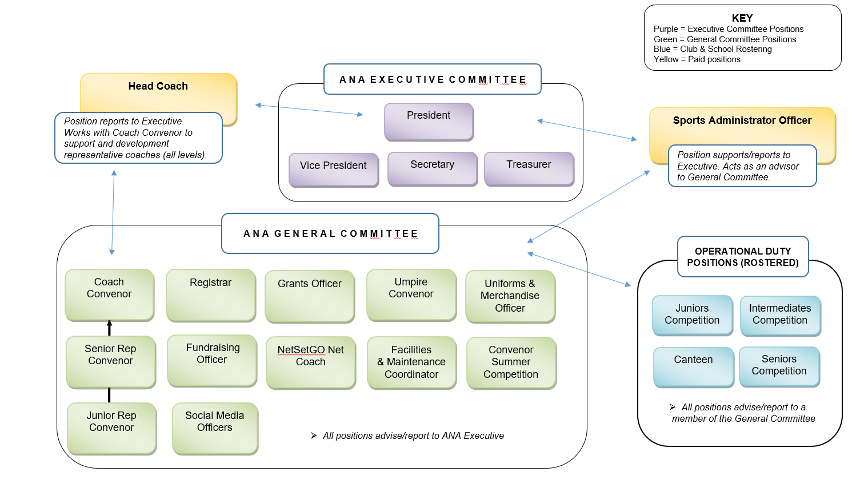

COMMITTEE ROLES AND DESCRIPTIONS

Executive Positions | Description
President | The role of the President is to provide the principal leadership and responsibility for the Association and the Committee. The President manages the legal and financial responsibility for all activities, maintains an overview of policy and strategic direction, represents ANA at Netball ACT (NACT) and District President meeting, attends ANA Executive and general Committee meetings and ANA/NACT AGMs, and must hold a current Working with Vulnerable People check.
Vice President | The role of the Vice President is to shadow the President in providing leadership and responsibility for the Association and the Committee, with an ability to assist the President where needed. The Vice President supports the President with District/Netball ACT representation duties, oversees the senior and intermediate competitions, attends ANA Executive & general Committee meetings and the ANA AGM, and must hold a current Working with Vulnerable People check.
Treasurer | The role of the Treasurer is to manage book-keeping and financial asset management of the Association. The Treasurer oversees the ANA registrar, and uniforms & merchandise officer, manages association purchases, spend request and budget, attends ANA Executive & general Committee meetings and the ANA AGM, and must hold a current Working with Vulnerable People check.
Secretary | The role of the Secretary is to assist the ANA Administration Officer to ensure record keeping and administration of the meetings of the Association. The Secretary oversees the maintenance of contact lists, court bookings, grants and fundraising, facilities, and maintenance requirements, attends ANA Executive & general Committee meetings and the ANA AGM, and must hold a current Working with Vulnerable People check.

General Committee Positions | Description
Junior Vice President | The role of the Junior Vice President (JVP) is to oversee planning and delivery of the Junior competitions (Years 2, 3, 4, 5 and 6) and the NETSETGO program. The JVP provides leadership and support to the 2/3/4 Convenor and the 5/6 Convenor, attends ANA general Committee meetings and AGM, and must hold a current Working with Vulnerable People check.
Registrar | The role of the Registrar is to manage team nominations, member registrations, and develop/maintain fixtures for all teams competing in the Saturday competition. The Registrar attends ANA general Committee meetings and ANA AGM and must hold a current Working with Vulnerable People check.
Umpiring Convenor | The role of the Umpiring Convenor (UC) is to manage all umpiring needs across Saturday and Junior Representative competitions/carnivals. Additionally, the UC develops and manages the delivery of the Junior umpiring program (JUMP), attends ANA general Committee meetings and ANA AGM, and must hold a current Working with Vulnerable People check.
Coaches Convenor | The role of the Coaches Convenor (CC) is to develop and maintain coaching capabilities across the Association. The CC facilitates the selection of coaches for the Association’s representative teams, liaises with the head coach to ensure development opportunities are delivered (all divisions), attends ANA general Committee meetings and ANA AGM and must hold a current Working with Vulnerable People check.
Senior Representative Convenor | The role of the Senior Representative Convenor (SRC) is to manage and coordinate the ANA senior State League representative program (U19s and Opens). The SRC is responsible for the communication with players and coaches, assists with registration, athlete trials and selections, and attends ANA general Committee meetings and ANA AGM and must hold a current Working with Vulnerable People check.
Junior Representative Convenor | The role of the Junior Representative Convenor (JRC) is to manage and coordinate the ANA Junior Representative Program (U11s to U17s), supporting players, coaches, and managers. The JRC is responsible for responding to all queries regarding the program, as well as delivering the management and coordination of the Arawang Junior Rep Carnival. The JRC attends ANA general Committee meetings, the ANA AGM and must hold a current Working with Vulnerable People check.
Seniors Convenor | The role of the Seniors Convenor (SC) is to manage and coordinate the Senior Winter (Saturday) Competition (A,B,C and Cadets grades). As SC you will be a point of contact at the pavilion for injuries, queries, and complaints during the allocated senior timeslots. This role includes record management (results/injuries/complaints), coordination of end of day pack-up duties (at the conclusion of the last game), and general assistant for existing or potential players. The SC attends ANA general Committee meetings and the ANA AGM and must hold a current Working with Vulnerable People check.
Inters Convenor | The role of the Inters Convenor (IC) is to manage and coordinate the Intermediate Winter (Saturday) Competition (Divisions 1, 2, 3 and 4). As IC you will be the point of contact at the pavilion for injuries, queries, and complaints during the allocated inters timeslots. This role includes record management (results/injuries/complaints), and general assistant for existing or potential players. The IC attends ANA general Committee meetings and the ANA AGM and must hold a current Working with Vulnerable People check.
5 / 6 Convenor | The role of the 5 / 6 Convenor is to manage and coordinate the Year 5 / 6 Winter (Saturday) Competition. You will be the point of contact at the pavilion for injuries, queries, and complaints during the allocated Year 5 / 6 timeslots. This role includes record management (results/injuries/complaints), and general assistant for existing or potential players. The 5 / 6 Convenor attends ANA general Committee meetings and the ANA AGM and must hold a current Working with Vulnerable People check.
2 / 3 / 4 Convenor | The role of the 2 / 3 / 4 Convenor is to manage and coordinate the Year 2 / 3 / 4 Winter (Saturday) Competition. You will be the point of contact at the pavilion for injuries, queries, and complaints during the allocated Year 2 / 3 / 4 time slots. This role includes record management (results/injuries/complaints), and general assistant for existing or potential players. The 2 / 3 / 4 Convenor attends ANA general Committee meetings and ANA AGM and must hold a current Working with Vulnerable People check.
NetSetGo ‘Net’ Coach | The role of the NetSetGo ‘Net’ Coach is to develop and manage the NetSetGo ‘Net’ program. You will be responsible for delivering the program as set out by Netball Australia, run the Net Skills and games session on Saturday mornings for 10 weeks, attend ANA general Committee meetings and ANA AGM and you must hold a current Working with Vulnerable People check.

Summer Comp Convenor | The role of the Summer Comp Convenor (SCC) is to manage and coordinate the Summer Competition for Juniors, Inters and Seniors on a weeknight (TBD). As SCC you will be responsible for the delivery of an 8 week competition, including being a point of contact at the pavilion for injuries, queries, complaints, and staffing of the canteen/pop-up bar. The SCC attends ANA general Committee meetings, the ANA AGM and must hold a current Working with Vulnerable People check.
Facilities Manager | The role of the Facilities Manager (FM) is to manage all grounds maintenance (courts and pavilion) and liaise with the ACT Government (as required). Unless requested, as FM you are not required to attend any competitions however attendance is required at ANA general Committee meetings and ANA AGM, and you must hold a current Working with Vulnerable People check.
Grants Officer | The role of the Grants Officer (GO) is to seek and engage in Grant opportunities in line with the Association’s master plan. As GO you will be responsible for the development and implementation of application processes, procure goods/services of successful bids, attend ANA general Committee meetings and the AGM, and hold a current Working with Vulnerable People check; you are not required to attend any competitions (unless requested).
Fundraising Officer | The role of the Fundraising Officer (FO) is to develop and coordinate the implementation of fundraising opportunities for the Association. As FO you are not required to attend any competitions where fundraising is not active, however you are requested to attend ANA general committee meetings and the ANA AGM, and you must hold a current Working with Vulnerable People check.
Uniforms and Merchandise Officer | The role of the Uniforms and Merchandise Officer (UMO) is to manage and coordinate uniform allocations for the Junior Representative program, as well as the planning and ordering of uniform stock and required merchandise through an annual stock take process. The UMO does not need to attend any competitions; however, you are requested to attend ANA general Committee meetings and the ANA AGM and must hold a current Working with Vulnerable People check.
Social Media Manager | The role of the Social Media Manager (SMM) is to monitor and activate content on ANA social media platforms (Facebook, Instagram, and Twitter). As SMM you will attend ANA general committee meetings and the AGM, and you must hold a current Working with Vulnerable People check; you are not required to attend any competitions (unless requested).

CONTACTS:

Committee Members

Position | Name | Phone | Email
Executive Committee
President | Rondelle Seden | 0409 667 655 | rondelle.seden@gmail.com
Senior Vice President | Cassie Turnbull | 0401 209 270 | cassandralturnbull@gmail.com
Secretary | Jackie Pratt | 0431 116 785 | jackie.pratt@act.gov.au
Treasurer | Suzanne Kelly | 0413 594 425 | purplesuz@me.com
General Committee
Junior Vice President | Vacant (2021)
Registrar | Amanda Kingston | 0431 611 617 | askingston@tpg.com.au
Facilities Manager | Vacant (2021)
Grants Officer | Vyt Vilkaitis | 0419 600 238 | vyt_vilkaitis@yahoo.com
Uniforms Officer | Rose Collins | 0410 475 116 | rose.collins05@gmail.com
Fundraising Officer | Amanda Kingston
Social Media | Belinda Major  Kira Tawton  Lilly O’Brien |  | Contact through FB Messenger
Umpires Convenor | Anne Barbic | 0417 407 329 | anne.barbic@cg.catholic.edu.au
Umpire Committee | Jodie Russell  Maureen Quodling | 0412 893 692  0407 665 715 | Jodieruss@bigpond.com  thequodlings@bigpond.com
Seniors Competition Convenor | Cassie Turnbull | 0401 209 270 | cassandralturnbull@gmail.com
Intermediates Competition Convenor | To be covered by Duty Roster
5/6 Convenor | To be covered by Duty Roster
2/3/4 Convenor | To be covered by Duty Roster
NETSETGO | Sheree Tawton | 0420 527 570 | fijisheree@gmail.com
Coaches Convenor | Kate Coffey | 0421 556 747 | coffey.kate@gmail.com  arawangcoach@gmail.com
Junior Representative Convenor | Heather Walsh | 0418 806 988 | Heather.walsh@bigpond.com  arawangjuniorrep@gmail.com
Senior Representative Convenor | Robyne Houston | 0403 213 949 | ronandrobyne@hotmail.com
Additional
Head Coach | Kim Symons | 0412 094 708 | kim.symons@netballact.com.au
Administrative | Melissa Bridge | 0422 420 720 | Arawangnetball@gmail.com

Club Contacts

Club | Name | Phone | Email
Warriors | Amanda Kingston | 0431 611 617 | warriorsnetball.ana@gmail.com
Royals | Kim Symons | 0412 094 708 | kim.symons@netballact.com.au
Saints | Nicole Crossley  Grant Faulkner | 0413 991 146  0430 828 862 | anasaintsnetball@gmail.com  crossley@webone.com.au  grantmfaulkner@gmail.com
Jetsetters | Robyne Houston  Kim Roscoe | 0403 213 949  0468 616 614 | ronandrobyne@hotmail.com  kimroscoe1@msn.com
Divas | Kim Magro | 0419 494 036 | kim.magro@outlook.com

School Coordinators Contacts

School | Name | Phone | Email
Arawang Primary School | Arawang P&C Netball | 02 6142 0660 | arawangpandcnetball@gmail.com
Chapman Primary School | Harriet Spinks  Rachel Henry |  | harrietspinks@yahoo.com.au  genoandrach@iinet.net.au
Charles Weston Primary School | Kim Magro (Divas) | 0419 494036 | kim.magro@outlook.com
Orana | Mike Brandy  Kathy Knight |  | Mike.Brady@oranaschool.com  Starfish@grapevine.com.au
Jetsetters | Robyne Houston | 0403 213949 | ronandrobyne@hotmail.com
Sacred Heart Primary School | Saints  Lilly Kennett |  | anasaintsnetball@gmail.com  lilly.k.010902@hotmail.com
St Johns Vianney’s Primary School | Sonia Dutkiewicz  Rebecca Battaglini |  | sonia.dutkiewicz@emersonhr.com.au
St Thomas The Apostle School | Katie Jenkins  Virginia Wilson |  | kjenkins@grapevine.com  vmaw@iinet.net.au

2022 WINTER SEASON CALENDAR

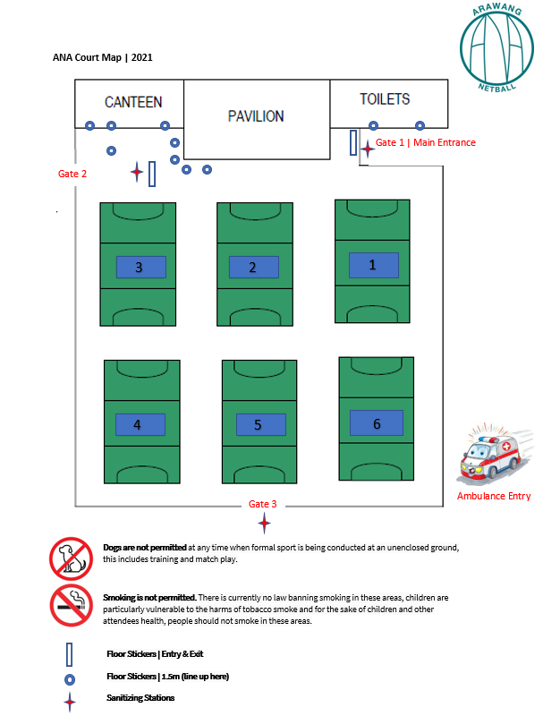

COURT MAP

